

The Standard is downloaded from www.bzfxw.com Standard Sharing

The Standard is downloaded from www.bzfxw.com Standard Sharing

The Standard is downloaded from www.bzfxw.com Standard Sharing

The Standard is downloaded from www.bzfxw.com Standard Sharing

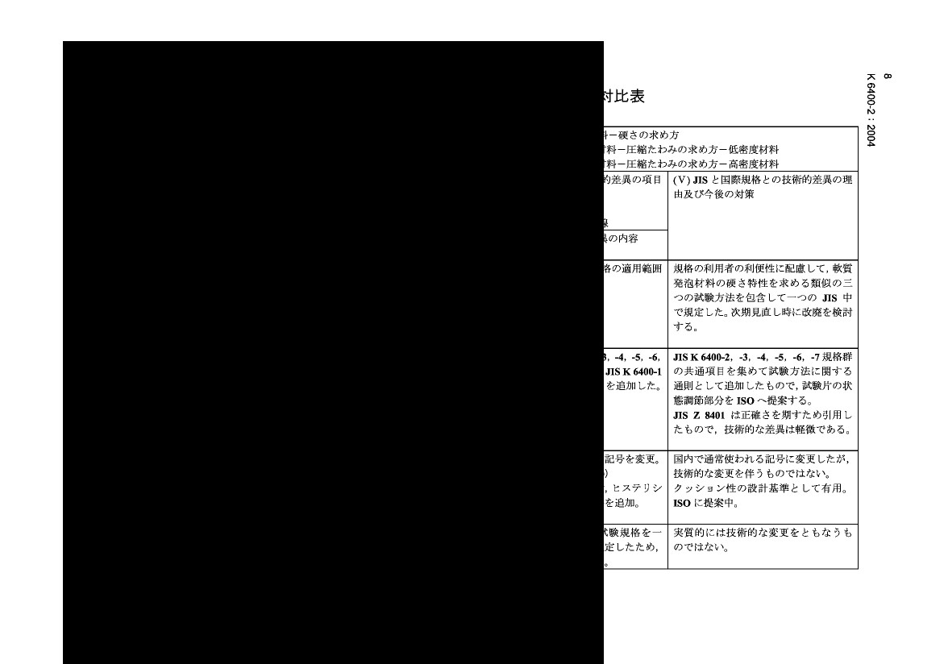
The Standard is downloaded from www.bzfxw.com Standard Sharing

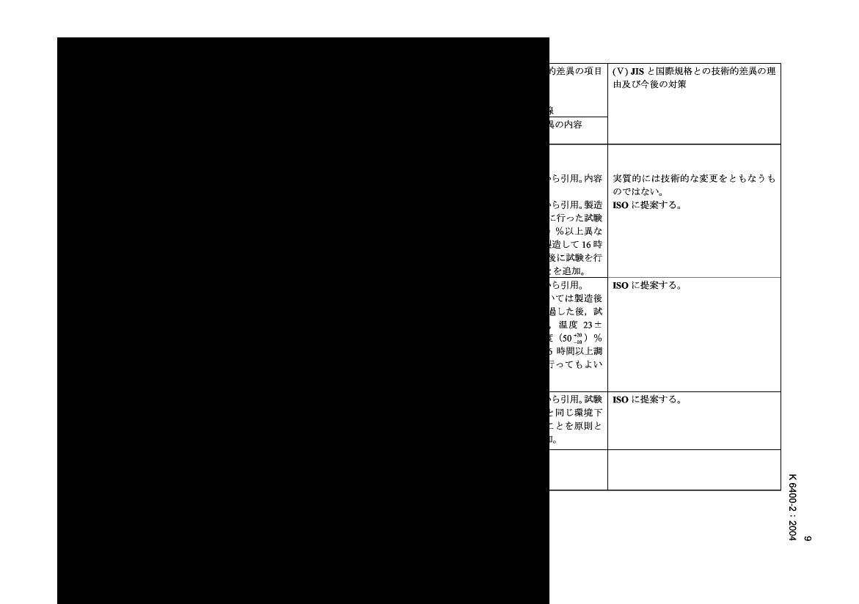
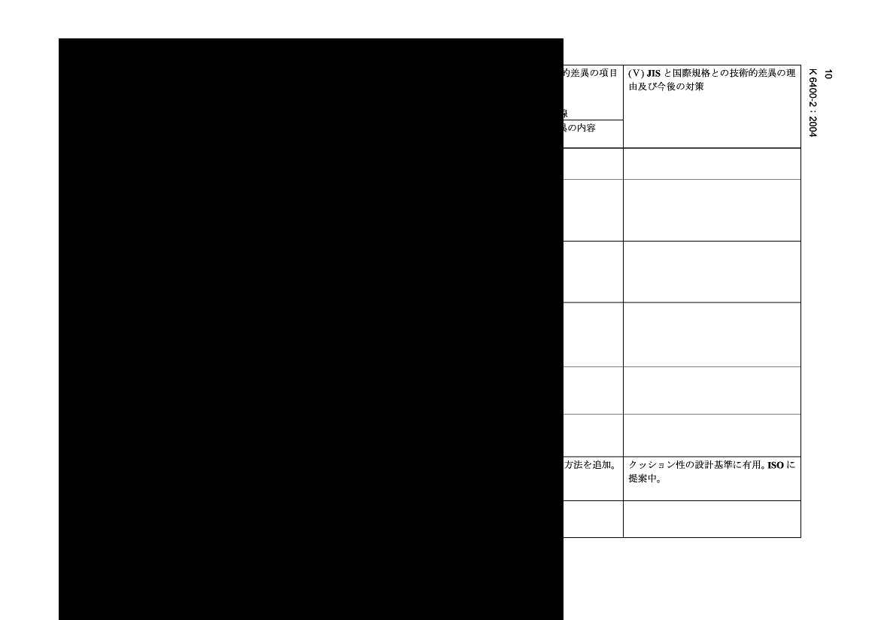
The Standard is downloaded from www.bzfxw.com Standard Sharing

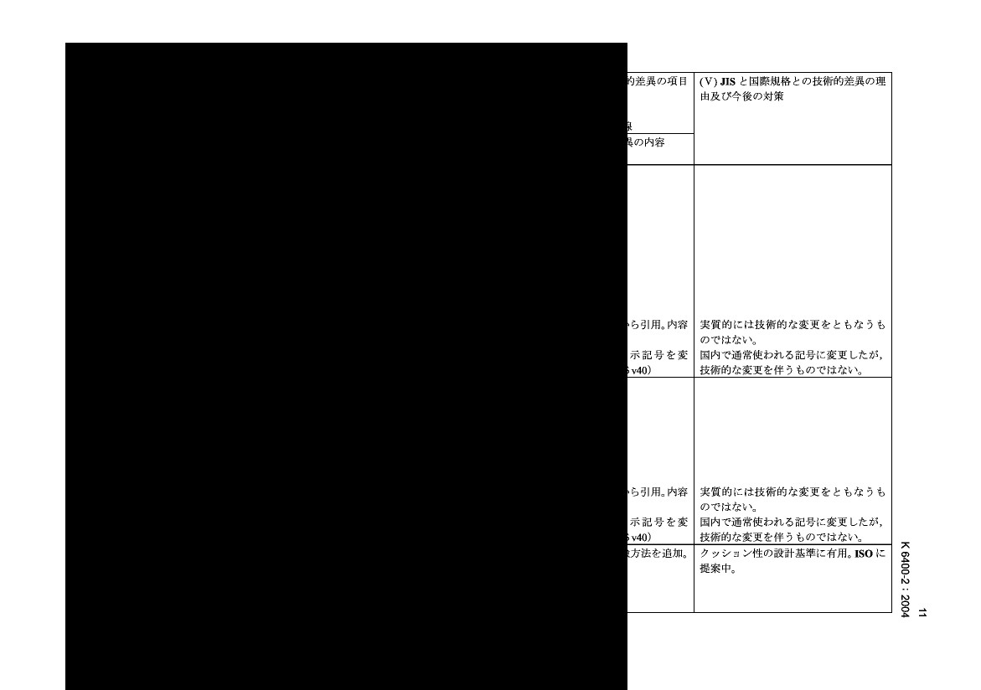
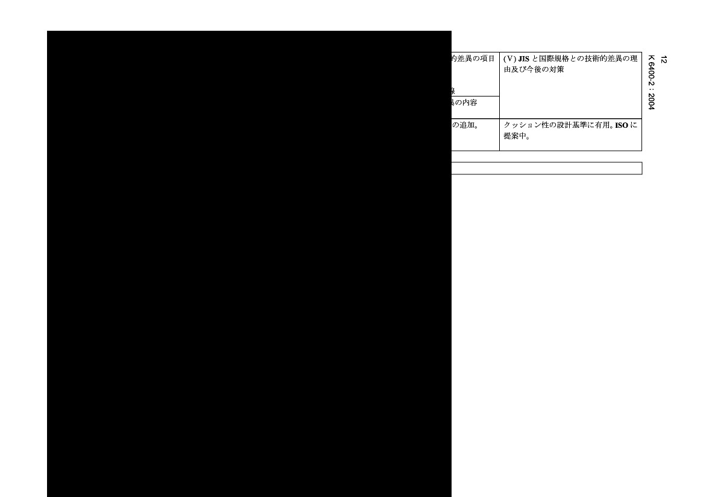
The Standard is downloaded from www.bzfxw.com Standard Sharing

