S.p.A. |  | 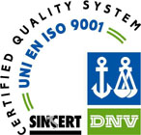

Critical Oxygen Index

A Quality System UNI EN ISO 9001 Company Certified

Critical Oxygen Index | 

Oxygen Index  Apparatus designed and built according to ASTM D 2863, ISO 4589-2 specifications and allowing to measure, with a precision of ± 0,1%, the minimum amount of oxygen required to support the combustion of a vertically set specimen alighted from the top.  The apparatus directly presents, as % and on a digital display, the amount of oxygen in a blend of oxygen and nitrogen flowing in the volume surrounding the specimen.  The apparatus is supplied equipped with accessories so as to perform tests on rigid specimens, flexible specimens and textile specimens.  The combustion chamber is made of pyrex glass.  Technical features  - System to let the blend of oxygen and nitrogen in the combustion chamber equipped with fine regulation valves, exclusion valves, gas filters, mixing chamber.  - Precision flowmeters to obtain the required concentration of oxygen and nitrogen.  - Paramagnetic detector of the oxygen concentration in the blend of O₂ – N₂  - Range 0 – 100% with an accuracy of ± 0.1%.  - Digital display presenting the oxygen content in the range 0 – 100%  - 2 scale expansions 0 – 25% and 0 – 50%.  - Dimensions: 600 x 350 x 350 h mm.  - Power: 220 V – 50 Hz – 0.1 kVA.  - Weight: approx. 20 kg.  Code 1004050 –  Spare parts and accessories  - Propane igniting system.  Code 1004052 –  - HI 8751 thermometer with HI 765PW probe.  Code 8768751 –  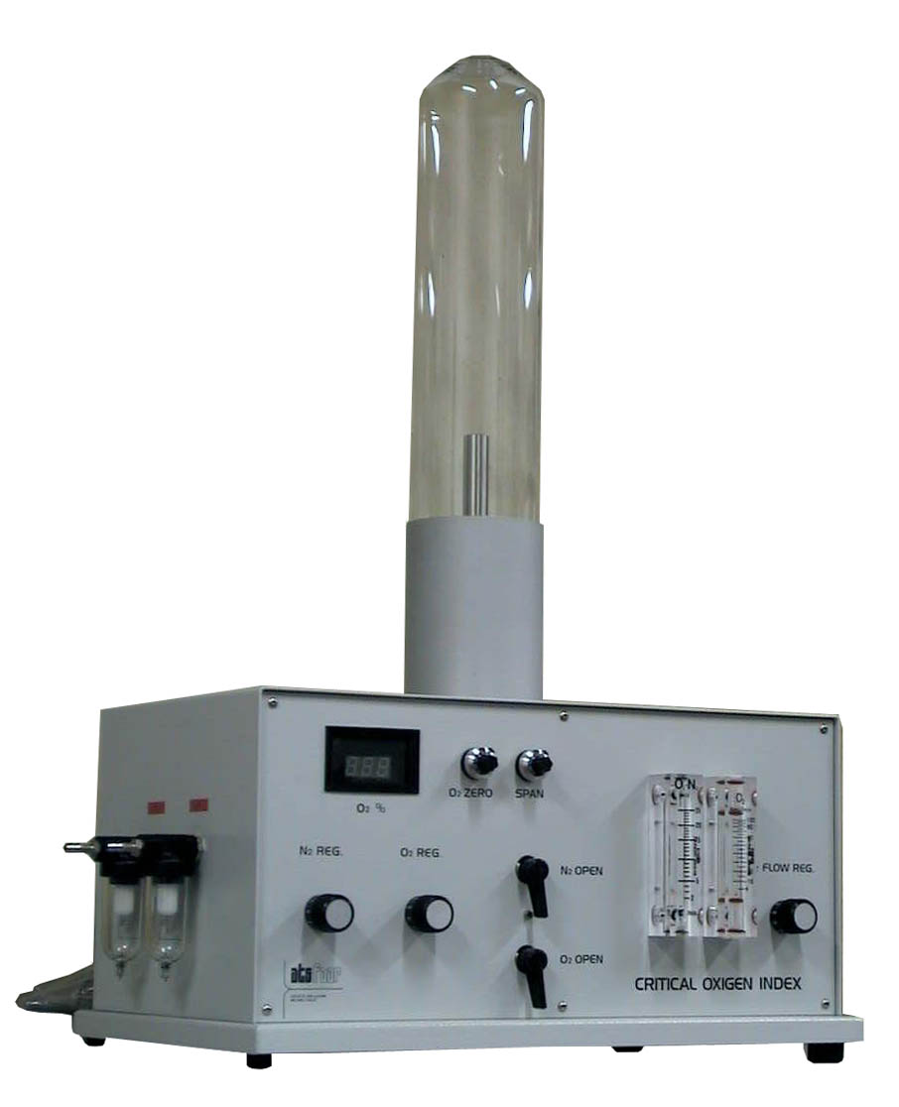  - Combustion chamber made of pyrex glass for O₂ index.  Code 1004066 – | Temperature index  This equipment allows to measure the minimum amount of oxygen required to support the combustion of the specimen, when the gas blend temperature is higher than room temperature with a maximum of + 400°C, furthermore allows to determine the minimum temperature at which the material will propagate the flame, i.e. the temperature at which the oxygen index is 21.  Basically it consists of a heating system electronically controlled in the range 0°C to + 400°C with digital presentation of the temperature, and of a flowmeter indicating the volumetric flow of O₂ – N₂ blend flowing in the test chamber during the tests.  The flow of O₂ – N₂ blend, previously metered by the basic apparatus, is kept at the constant speed of 4 + 1 cm/s” by a proper pump.  The flowmeter, the temperature regulator/indicator, the pump, the switches and the warning lights are housed in a separate control cabinet whereas the heater is located under the pyrex test chamber, which is surrounded by a second pyrex tube so as to obtain a good thermal insulation.  - Power: 220 V – 50 Hz – singlephase – 20 A.  - Dimensions: 400 x 300 x 700 h mm.  - Weight: approx. 20 kg.  Code 1004070 –  Spare parts and accessories  - Normalised igniting system for temperature index.  Code 1004055 –  - Spare gas bottle for 10.04055.  Code 1004056 –  - U – shaped support for soft specimens for oxygen and temperature index.  Code 1004058 –  - Support for rigid specimens.  Code 1004059 –  NOTE:  To correctly perform the tests it is suggested to use oxygen and nitrogen pure for gaschromatography.  It is also suggested to periodically check the apparatus calibration using an O₂ – N₂ blend having a known concentration.
Indications reported on this bulletin may be changed without notice. Codes and references for informative purposes only.

Ref. 87e of 11 - 2001

Strumenti Scientifici per Prove Fisiche, Laboratori “Chiavi in mano”, Arredi per Laboratori, Prodotti Chimici & Reagenti
Testing instruments for physical tests, “Turn key” LaboratoriesTechnical furnishing, Chemicals and reagents.
20060 Vignate (MI) Italy Via Camporicco, 1 Phone + 39 02 9593921 Fax + 39 02 95360686 – 02 95360113
e-mail: atsfaar@atsfaar.it http://www.atsfaar.it

A Quality System
UNI EN ISO 9001
Company Certified

We are the Staff of the Technical Furniture Division of ATS FAAR, we design and produce all the furniture lines basing on ISO 9001 certified procedures and that is impor-tant each piece is manufactu-red in our facilities.

R & D Department cooperates with our Division to upgrade our furniture in

